Summary of the Ark in the Park Kokako Breeding Season 2012-2013

Andy Warneford.

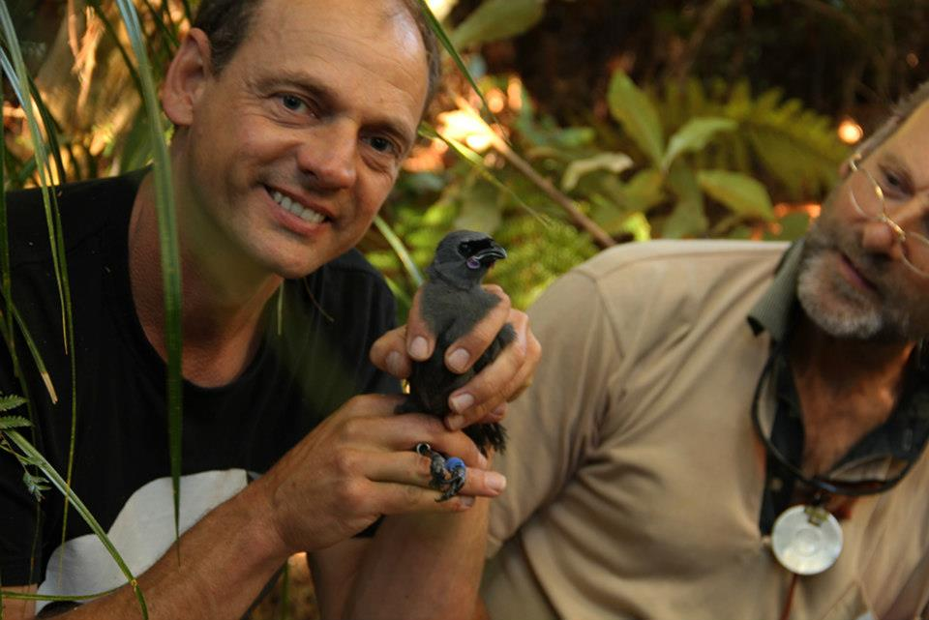
Photo taken by Evan Cameron
Contents
Abstract 3
Background 4
Predator Control 5
Translocations 5
Survey Results 6
Genetics 8
Monitoring requirements 8
Recorders 9
Choice of Habitat 9
Teams 10
Volunteer workers contribution 10
Discussion 11
References 13
Appendices 14
Appendix 1 14
Appendix 2 16

Abstract
Early indicators for the re-introduction of North Island kokako (Callaeas cinerea wilsoni) are promising. Eight known pairs have been identified in the Ark in the Park (AiP) management area. There are five surviving single founders, and conservatively 12 progeny birds (first generation) AiP birds have been produced. The total population in the managed area therefore is around 33 birds.
The Kokako Recovery Group (KRG) requires a minimum of 30 “founder” birds to be recruited before a translocation is considered to be complete.
The KRG also requires yearly monitoring of the species following re-introduction until 25 breeding pairs have been established. At which point, a viable population is considered to be established.
One of the pairs, (kiekie/unbanded) obviously includes a progeny bird, so they do not count as recruited breeding founders.
An important distinction needs to be made between “Complete Translocation” and “Successful Re-introduction”. Neither has occurred yet at the AiP project.

Background
The Ark in the Park (AiP) is a mainland conservation project based at Cascade Kauri Park in the Waitakere Ranges Regional Park, west of Auckland City (Figure 1). It is a joint project between Forest and Bird (Waitakere Branch) and Auckland Council with most of the pest control carried out by volunteers. The aim of the project is to restore functioning native ecosystems through pest control and the re-introduction of native species that have been lost from the area. The project started operating on the ground in 2003 and has since grown to approximately 2500ha, with an additional 600-700ha of pest control on neighbouring private properties (the Buffer Zone). The AiP is an open sanctuary so does not have a predator proof fence, and instead uses ongoing intensive pest control to keep mammalian predator numbers at low densities. The success of the project has allowed the re-introduction of popokatea (mohoua albicilla), North Island robin (Petroica australis longipes), Hihi (Notiomystis cincta) and North Island kokako (Callaeas cinerea wilsoni) to occur. Early indications for popokatea, toutouwai and kokako are promising (Waite 2011).

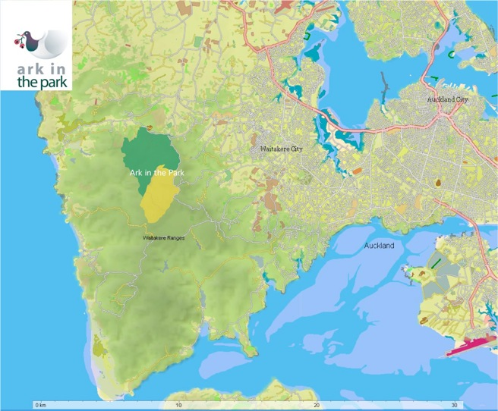
Figure 1: Location of Ark in the Park open sanctuary in the Auckland Region.

Predator Control
Predator control is targeted at rats, mustelids, possums and feral cats. Rodent control is carried out by providing “year-round” availability of Brodifacoum baits (“Pest Off”), with the aim of reducing rat numbers below the 5% activity index over the September to February period. Bait in sealed plastic bags is placed in Philproof bait stations set out on gridlines throughout the entire management area, with two different spacings used throughout the project; 100m × 50m and 100m × 100m. Monitoring is carried out using tracking tunnels. Activity indices from the 2011-2012 kokako monitoring season are shown below (Table 1). Mustelid control is carried out using Fenn traps, enclosed within plastic tunnels, and DOC200 traps placed at 200m spacings around the periphery of the management area and along existing tracks within it. During the kokako monitoring period (August 2011 to March 2012) 101 stoats, 4 ferrets, 13 weasels and 182 rats were caught.

Date | Percentage of tunnels with tracks Relative density percentage %
6 August 2011 | 6.0
16 January 2012 | 2.9
26 March 2012 | 6.7
February 2013 | 2.1

Table 1: Rat monitoring results from the Ark in the Park during the 2011/12/13 kokako season.

Translocations
Kokako were first released in the Ark in the Park in 2009 with the aim of introducing 30 kokako as founders to establish a self sustaining population in the long term. In 2011 a further four kokako (two male and two female) from Waipapa were released and anchored with sound anchoring. This takes the total number of kokako reintroduced to 26 (12 female, 11 male, 3 sex unknown) from four different source populations; 10 Waipapa, 3 Mapara, 11 Tunawae and 2 Tiritiri Matangi over the 3 year period. A summary of kokako translocations into the Ark in the Park is given below (
Table 2).
Date | Source | Birds
Sept - Nov 2009 | Waipapa | 4 female, 2 males
May 2010 | Tiritiri Matangi | 1 female, 1 male
Sept 2010 | Mapara | 1 female, 1 male, 1 unknown
Oct 2010 | Tunawae | 4 female, 5 male, 2 unknown
Sept – Oct 2011 | Waipapa | 2 female, 2 male

Table 2: Summary of translocations to the Ark in the Park 2009 - 2011

Survey Results
The survey period ran from August 2012 to March 2013. Eight breeding pairs have been identified in the pest management area. It should be noted that one of these pairs includes a progeny bird born in the AiP. Therefore, this pairing of Kiekie (M/YLg)/un-banded, does not contribute the breeding pairs made up of founders. The Kokako Recovery Group KRG requirement is for 15 pairs made up of founder birds to be established, before a translocation is considered complete.
The AiP population also includes five single founder birds, plus a number of progeny birds including a banded bird produced this season, and three banded birds from previous seasons. See (Table 3).
Conservatively based on the standard breeding rates for the species, the total population of kokako at the AiP is around 33 birds.
The location of all identified individuals is shown in Figure 2, along with areas kokako were heard but not positively indentified, that may be of use for the 2013 - 2014 season.
There continues to be single birds heard in the southern areas of AWS, CGN, CGS, KOK and IW blocks, as heard by field workers, and also picked up on the recorders developed by Eric Wilson. These birds do not appear to be territorial, but no doubt anchored to the area due to the species social nature, and the reasonable density of birds that are territorial to this general area. A number of these birds have been single in the project now, more or less since re-introduction. It is fair to assume they may well not pair with other founder birds, but as the number of progeny birds increases, they may well be recruited into the breeding population, such as kiekie has been.
Note: In the instance of this occurring, these birds will not count as breeding founders, as their genetics are from the existing pool available (Hazel Speed, DOC).

Founder Capture site | Band combinaison | Sex | Name | Status
Waipapa site 7 | M/RG | M | Maurice | pair
Waipapa site 6 | M/RLg | F | Kowhai | pair
Waipapa site 5 | M/WG | M | Totora | pair
Waipapa site 7 | M/WY | F | Puke | pair
Tunawae-middle pair | M/WR | ? | Sylvain | pair
Waipapa site 4 | M/RW | F | Karen | pair
Waipapa | M/YG | M | Marty | pair
Waipapa | M/YB | F | Manuka | pair
Tunawae-Nth Ea access | M/GR | F | Rhonda | pair
Tunawae | M/YW | M | Dylan | pair
Tunawae-middle pair | M/YLg | ? | Kiekie | pair
Unbanded |  | ? | - | pair
Tunawae - pair | M/GY | F | Sophie | pair
Tunawae - pair | M/YR | M | Pierre | pair
Unknown | - | ? | - | pair
Unknown | - | ? | - | pair
Waipapa site 7 | M/RB | F | Wahine | Not seen since release
Tiritiri Matangi | OM/Y | M | Moby | Single
Tiritiri Matangi | YM/R | F | Punga | Not seen since 2011
Mapara- (South) | M/WLg | M | Nikau | Single
Mapara-Rain1 (South) | M/BR | F? | Rata | Single
Mapara-Rain2 (South) | M/BW | F | Maire | Not seen since 2011
Tunawae | GLg/M | F | Pareira | Single
Tunawae-Rain | M/GW | F | Grace | Not seen since 2012
Tunawae-Nth Ea access | M/RY | M | Duncan | Not seen since release
Tunawae-Owawenga | M/LgY | M | Lucy | Not seen since 2011
Tunawae-Owawenga | M/LgR | M | George | Not seen since 2011
Waipapa | M/GB | M | Rimu | Not seen since 2012
Waipapa | M/LgW | F | Kauri | Single
AiP | R/GM | M | Miro | Not seen since 2011
AiP | Lg/YM | F | Brittany | Not seen since 2011
AiP | WB/M | M | Matai | Not seen since 2011
AiP | BB/M | ? | Andy | Fledged

Table 3: Summary of Ark in the Park banded kokako population at the end of the monitoring season, March 2013.

Genetics
From the above survey results, an important point needs to be considered by the project. The DOC requirements via the KRG have already been mentioned, but perhaps need expanding here. A large number of birds, does not necessarily mean a large genetic diversity.
Contact: Emily King <eking@doc.govt.nz>.
Once a species has been through a “genetic bottle neck”, such as occurs in the process of a translocation, even then a large number of individuals that is produced by the subsequent population DOES NOT produce a large genetic diversity. Also, genetic variation that occurs due to mutation and evolution, takes place over many thousands of years.
The only way to avert the many serious risks of genetic bottling necks, such as high vulnerability to disease, inbreeding depression and behavioural disorders, is to add genetics to the population, from different founder groups, IMPORTANT!.
This actually applies to all species at the AiP project, toutouwai, popokatea and kokako alike. The negative effects of inbreeding depression have probably already been seen at this project with its early NI Robin population. See Marsha Leenan’s report on AiP robins, and her comments about the number of infertile nests and eggs. This was not proven to be the direct result of inbreeding depression, but it does raise concerns. Especially, when one considers that since the introduction of more NI Robin, from a different, and, more genetically diverse population i.e. not from and isolated island, seems to have removed this problem. However, there is probably more work yet to be done in this area at AiP yet, with that species.
The negative effects of genetic limitation has been seen in spectacular fashion at Tiritiri Matangi, and as a consequence, intensive “genetic management” is carried out there, including the use of “egg swap” methods, with outside populations (Hazel Speed, DOC).

Monitoring requirements
Following any translocation of kokako, DOC and the KRG require ongoing yearly monitoring of the species until 25 breeding pairs are established inside the pest managed recipient location.
This is fundamental to the success of the species for various reasons including genetics, vulnerability to stochastic events, losses to due to predation, disease and post translocation stress and other natural losses sustained by any population, established or otherwise.
Resulting from meetings with Hazel Speed (DOC), a summary of discussions with the KRG that will be included in the yet to be release new recovery plan is documented in Appendix 2.

Recorders
The powerful effectiveness of the recorders used in the project, developed by AiP volunteer Eric Wilson, cannot be over stated. The development of this technology by Eric, is now been viewed by other large kokako recovery projects (Hunua kokako management area, David Bryden) as being the way of the future for the bulk of their survey work.
The recorders were instrumental in the initial “clues” that lead to the finding of at least two breeding pairs, and are very powerful in the establishment of where territorial boundaries lay. These two aspects are essential in the assessment of the success of the reintroduced population.
As with any highly effective use of tools in a project of this size goes, the involvement of “teams” is essential. Kevin Ferguson, and Jeremy Painting put in huge hours deploying and recovering recorders (on the same day to allow reprogramming and recharging) all over the project, and this work continues.
I suggest that this survey technique continue for as long, and a sustained a period as possible. So long as Eric and the team mentioned above are happy to keep this work going, it will undoubtedly produce new information for AiP about its growing population.

Choice of Habitat
The southern areas of the AiP continue to produce the best results for kokako. The difference between the habitat in this area, and the original northern areas of the project, are quite notable. As John Staniland eloquently noted... “A walk along the Nihotupu trail (southern boundary of the project) is like feasting on a veritable smorgasbord of botanical delights”.
The understory in this area is of particularly complex nature, and dense. This enables the ecology to carry a high rate of biomass per hectare, as verified in recent Auckland Council biodiversity surveys.
Out of interest this places the Waitakere ranges unmanaged biomass/ha at roughly equivalent to Little Barrier Island and Kapiti Island. In managed areas such as AiP, it is actually higher than both.
This bodes well for kokako in the area, so long as pest control is maintained to a high standard. Increasing the size of the managed area will benefit all biodiversity, both in those new areas, and the existing area of AiP.

Teams
As with previous years, it must be noted that reliable, fit, keen team members, that are keen to learn the skills required to monitor any species are essential. Many of these skills are fairly basic, such as map reading, navigation, radio operating, bush craft and identifying calls. However, some skills to seem to be the reserve of individuals with a “talent” in these specific areas, such as indentifying individual birds, interpreting detailed information to establish the bigger picture, and interpreting the behaviour of the birds, and their movements.
Efficient, motivational, planned and supported field team management, it goes without saying, is absolutely essential.
At this point again the efforts of Evan Cameron, Asha Rodger, Thomas Knight, Kevin Ferguson, Grant Capill and Jeremy Painting, with the support of Laurence Bechet (maps etc) cannot be over stated.

Volunteer workers contribution
On occasions volunteers have joined the monitoring teams in the field, and made very useful contributions. With other species such as toutouwai, the volunteer’s contribution is almost critical such as Heidrun Schinke’s work on monitoring, and more recently banding of NI robin in the field.
Kokako monitoring though requires very early mornings, a moderate to high level of fitness, ability to work off track, indeed off bait line, skills such as radio, compass and map navigation, and probably most importantly, ability to read bands on a birds leg. The last requirement noted here, band reading, is probably the one skill that few people develop to a high level. Most volunteers don’t have the opportunity to spend enough time in the field to develop this particular skill, and indeed, even many people that have done hundreds of hours in the field with my teams, never quite master this. My best individual read was while I was early morning monitoring with John Sumich and Hayden Reynolds, and we had huge response to playback, which resulted in two pairs dueting simultaneously on the Nihotupu trail. At one point I manage to spot a bird in a tree around 200m off, across the stream into unmanaged areas. I locked the bird in on binoculars, and just for a split second the bands on the bird caught the very early morning sun, and I was able to confirm the bird as Totara. We confirmed 4 birds positively that morning. Most mornings don’t go quite that well, but it shows in what a top team can achieve.
Another very important part of monitoring kokako at AiP in particular, is the need for well cleared and marked bait lines. The density of the vegetation at the project is so dense, especially in the southern areas, that movement off track for the purposes of following a kokako on the move is practically impossible. However, as my knowledge of the lines got better, and the lines cleared better with time, I was able to roughly know where we could and couldn’t pursue birds. This avoided dragging teams through “walls” of kiekie and supple jack, and instead often set up grids of people enabling as to positively ID birds, and importantly their territories.
Bruce Calvert’s contribution in this area of bait line clearing has been stellar, and I feel he should be rewarded in some way, as with previous seasons.

Discussion
Two nests were confirmed as found, with a fledgling banded from one, at AWS6, Maurice/Kowhai nest during the 2012-2013 season. As in the previous season, with the low number of nests monitored, it is impossible to assess the risk of predation to nests in the project. However, it should be noted that the “ring of steel” placed around the nest mentioned above, produced zero kills. This is a first for the project, and possibly indicates the high level of overall pest control being achieved by the wildlife management practices now being employed at AiP.
A harrier hawk was also frequently observed flying low over the nest tree at AWS6, which was in an open area of forest (John Staniland et al). Despite these threats the single chick successfully fledged.
It was interesting to note the behaviour of Maurice/Kowhai while actually banding the chick. During this process with the chick of the same pair, over the previous two seasons, it was observed that the parent birds did seem more than a little concerned at our behaviour with the chick. However, this year, the third time the parent birds have observed our banding operations, they seemed almost uninterested in proceedings, and watched from a nearby tree, without making a single call. As soon as the chick was placed back in the nest, they peacefully returned to the chick with food.
A shift in monitoring philosophy worked well this season. I made the focus of my work, and that of contracted survey assistant Evan Cameron (who performed extremely well), the finding of breeding pairs, their territories and the movements of other birds in and around these territories.
A separate team was provided by Asha Rodger of the Auckland Zoo (AC), comprising a bird specialist of international experience, Thomas Knight. Other members of the zoo staff also assisted as the zoo roster allowed. Some of the hours provided by the zoo team was done either on leave from the zoo, or in the team members own time. The zoo has a “Conservation Fund”, which was utilised to supply staff and a vehicle when possible. The zoo provided the use of a 4X4 vehicle on most days the team was in the field.
I trained this team in the skills of nest finding, which enabled Evan and myself to focus on the tasks mentioned above.
While the nest finding team did struggle to add any nests to the overall tally, they did learn important skills, and as the season progressed, were then able to transfer these skills to general survey duties, which was immensely helpful. These skills of course can now all be utilised in the future by this project, and others. The fact the team struggled to find nests, it would have to be said, was entirely due to the density of the vegetation in the areas of known territories. The team itself was operating to a high level of skill, reliability, enthusiasm and talent.
Part of the success of this team was their willingness to utilise the Alpine Sports Club (ASC) mountain hut for overnight trips. These trips enabled very early starts, in distant areas of the project that would simply not be practicably possible were people needing to travel across Auckland, to be in the ranges, on site, and in position at around 5am in the morning!
AiP covered the food costs and fees of the hut, which ASC provided to AiP at a discounted price.
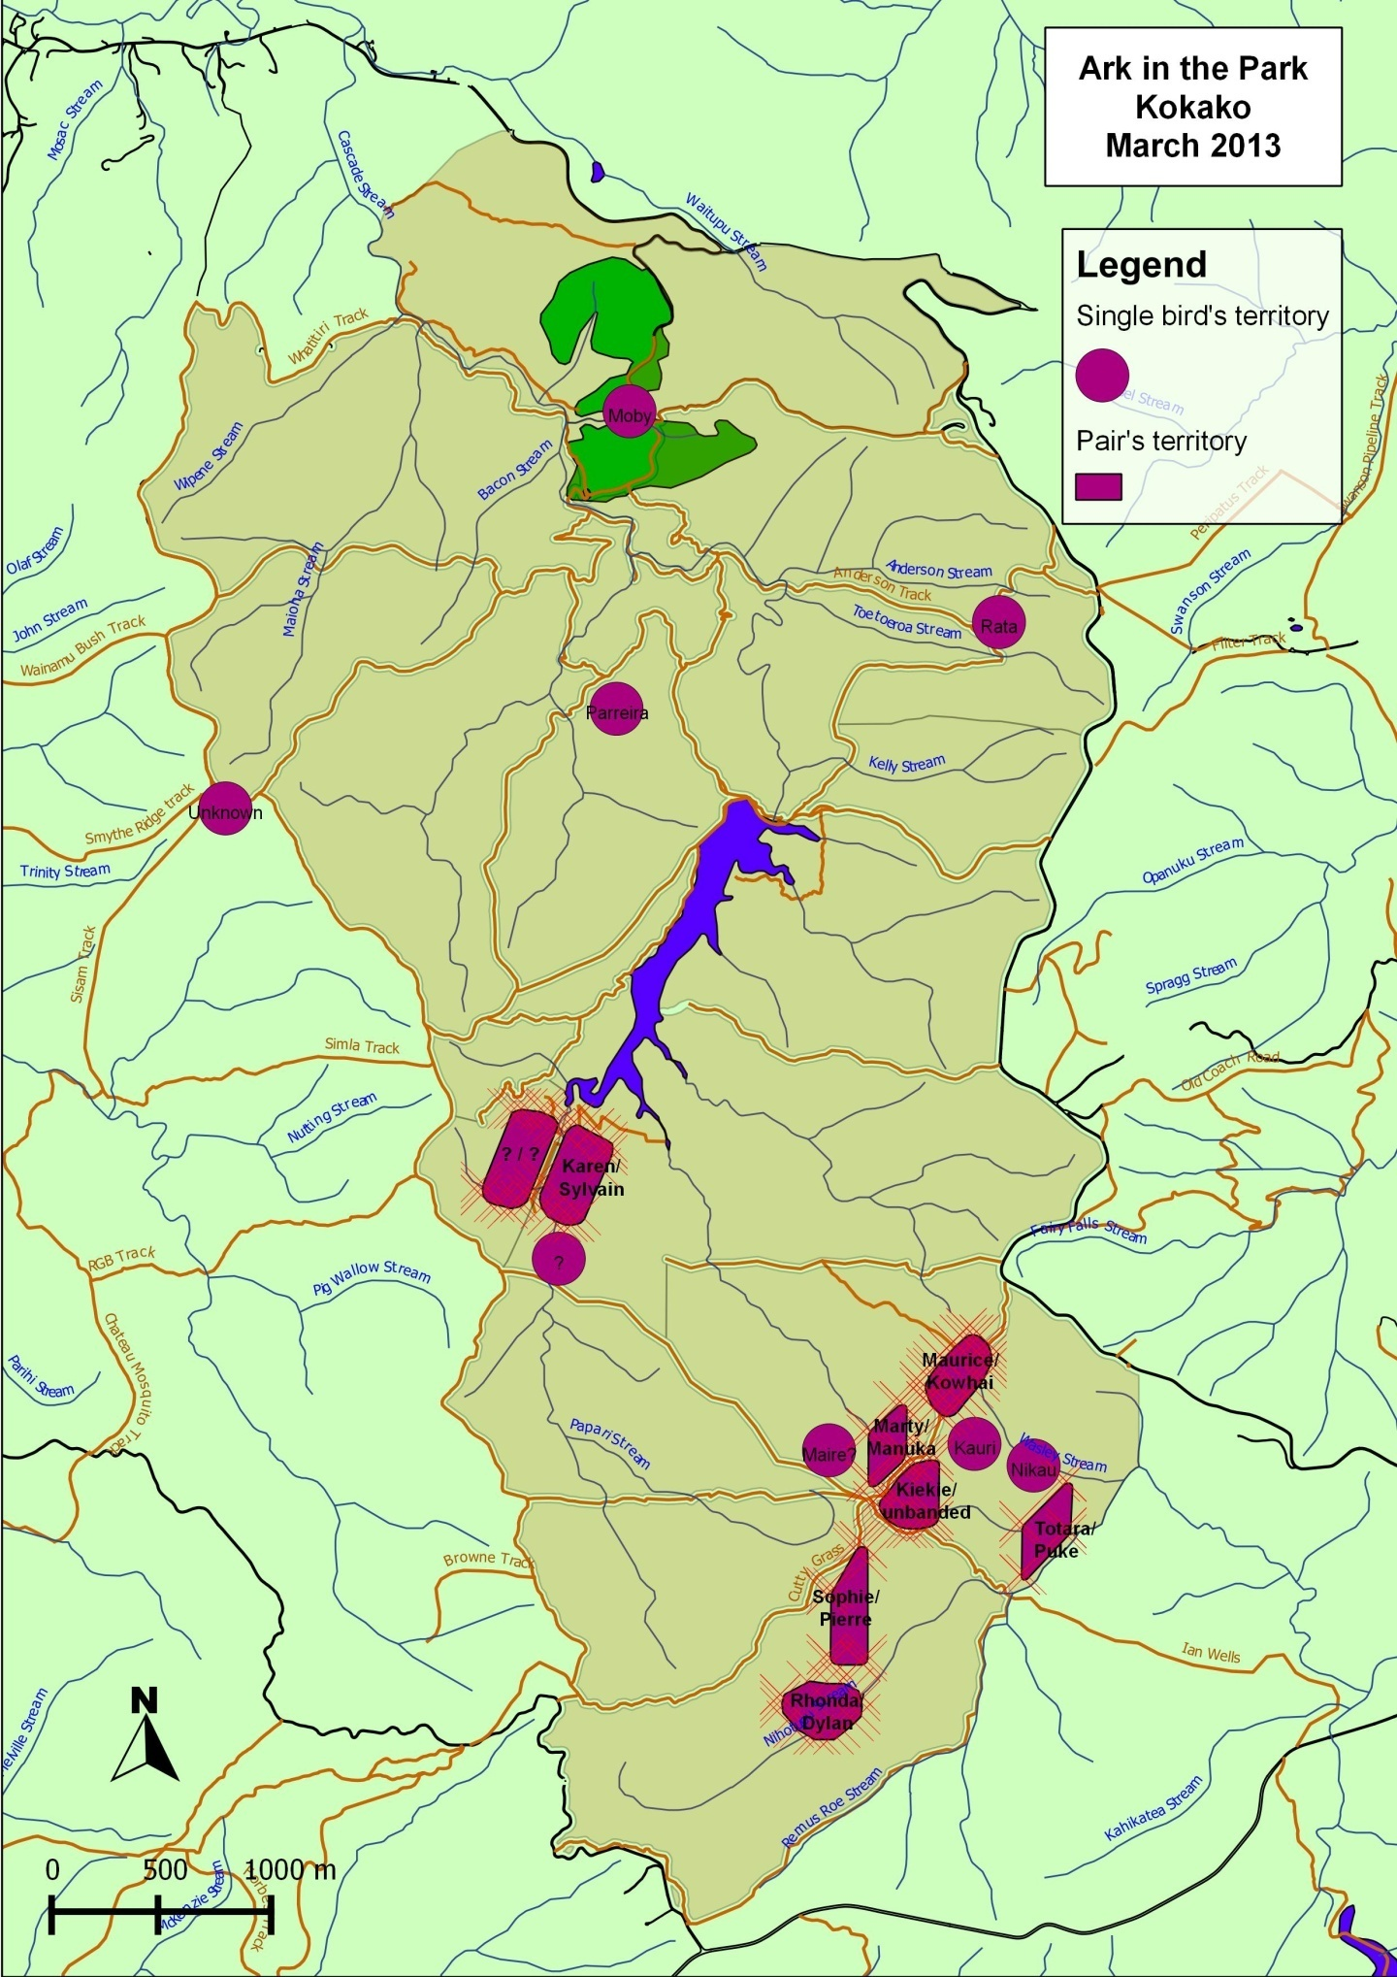
Figure 2: Map of the Ark in the Park showing the location of kokako territories held by pairs and singles, locations where kokako were heard but not identified.

References
Waite, J. (2011). Ark in the Park kokako report: 6.

Acknowledgements
Ark in the Park is a collaborative project between Forest and Bird and Auckland Council supported by Te Kawerau a Maki.
Thank you to the main financial supporters ASB Community Trust and The Trusts Community Foundation (TTCF).
In addition, thank you to the Auckland Zoo who provided financial support as well as significant expertise and time in the field. Finally thank you to all the Ark in the Park volunteers, especially those people mentioned earlier in this report.

Appendices

Appendix 1

AK-25979-FAU
NHS-03-21-19
DOCDM-469641

AUTHORITY TO CAPTURE, HANDLE, TRANSFER AND RELEASE ABSOLUTELY PROTECTED WILDLIFE

PURSUANT to Sections 53 (2) of the Wildlife Act 1953 and Section 51 of the Reserves Act 1977:

Maj de Poorter Paul Jansen
Project Manager 4 Scoresby Grove
Ark in the Park Whitby
Forest & Bird Porirua
34 A Charlotte Street 5024
Eden Terrace
AUCKLAND

This permit authorises the Permit Holder to catch up to 30 North Island kokako (Callaeas cinerea wilsoni) from the Waipapa and Mangatutu Ecological Areas, with not more than 20 kokako taken from each site, between 24 August 2009 and 31 October 2012 under the conditions listed below:

1. The Permit Holder must contact the Maniapoto Area Office at least one week prior to commencing each period of kokako catching at the approved sites.

2. Catching of kokako at the approved sites must cease from 31 October to 30 March each year (no catching during the breeding season). From 1 October to 31 October an experienced kokako observer must follow any pairs at the planned catching location prior to catching commencing to confirm that the female is not about to lay eggs. An alternative catching location must be used if a female is thought to be ready to lay eggs.

3. The Permit Holder must strictly adhere to the instructions described in the Kokako Best Practice Manual (September 2008) and the approved translocation proposal “Translocation Proposal for North Island Kokako to Ark in the Park Open Sanctuary”, with regard to all kokako catching, handling, banding, transfer and release activities.

4. The Permit Holder must ensure that at least one person experienced with mist-netting and kokako handling is present and supervises all personnel at each mist-netting site. Mist-nets must be attended continuously by an experienced person at all times while nets are open.

5. This permit does not authorise access over any private land, lease land or land administered by other agencies. The Permit Holder must obtain permission from the appropriate land owner, lease holder or land administrator prior to crossing, accessing or conducting the activities described in Schedule One of this permit.

6. The Permit Holder must ensure that all field equipment is washed and clean prior to entering the approved catching sites. Equipment must be sealed in containers so both the Permit Holder can be certain it is free of rodents and invertebrates. The Permit Holder must ensure that all kokako catching and handling equipment is thoroughly cleaned with Trigene and free of mud and seeds before entering a sampling area to prevent the spread of weeds, pathogens and diseases.

7. The Permit Holder must not impact on any other absolutely protected species, research or management activities at the approved catching sites.

8. The Permit Holder must ensure that the kokako or any bird caught is handled as carefully as possible, but if any should die, the body is to be handed in to the Maniapoto Area Office as soon as possible, along with any relevant details or circumstances. Appropriate measures shall be taken to minimise further deaths.

9. The Permit Holder must release any banded kokako caught at the approved catching sites at their point of capture and as soon as possible after capture.

10. The Permit Holder must provide to the Maniapoto Area Office a brief report summarising the number and location (location coordinates derived from a GPS device) of kokako caught and transferred upon the completion of catching each season. Location coordinates of unsuccessful catching sites shall also be provided.

11. Mist net haul lines are to be left in place at each catching site, for use by other parties. No mist net lines shall be left unattended at any place where they may endanger the public (e.g. across quad tracks).

12. The Permit Holder must ensure that only the absolute minimum of tree felling or vegetation clearance is occurs at each catching site.

13. The Permit Holder must remove all track markers placed for the purposes of catching at the completion of catching at each site.

14. The Permit Holder must collect faecal samples where practicable from individual birds either from bird bags or from the holding aviary. These samples must be then sent to Richard Jacob-Hoff vet Auckland Zoo to be screened for coccidia. If coccidia is detected Baycox will be applied to that particular individual by Richard Jacob-Hoff prior to release.

15. Post release monitoring must follow that as described in Section 12 of the approved Translocation Proposal.

16. A report on the completed operation must be presented to the Auckland Conservator and Area Manager Auckland Area, Department of Conservation, Private Bag 68908, Newton, Auckland, and the Waikato Conservator, Department of Conservation Private Bag 3072
Hamilton 3240 within two (2) months of the transfer.

17. Annual monitoring reports must be presented to the Auckland Conservator Auckland, Department of Conservation, Private Bag 68908, Newton, Auckland, and the Waikato Conservator, Department of Conservation Private Bag 3072
Hamilton 3240.

Unless sooner revoked or varied this authority is valid for twelve (12) months from date of issue.

SIGNED by  Sean Goddard  Auckland Conservator  On the 2009.  ACTING FOR AND ON BEHALF OF THE  MINISTER OF CONSERVATION  ("the Grantor") pursuant to a written delegation in the presence of:  _  ________________________________________ | Permit not valid until read and signed by Permit Holder(s):  Maj de Poorter  Project Manager  Ark in the Park  Also for:  Paul Jansen  Capture team leader  By signing this you the Permit Holder(s) agree to the conditions of the Permit.

Appendix 2

Objective 3.1: All managed populations are monitored appropriately (as robustly as possible within practical and financial constraints) for the relevant stage of their recovery.

Action | Accountability | Priority
3.1 Census population size annually at all newly established populations and populations of less than 25 breeding pairs . | AM or Project Manager person at each recovery site. | High

